**Proposed plan for Priority 1**

After conversations with people, I understood that the cost of hosting website will be same irrespective of the tech stack used; be it WordPress, or an alternative to it. The cost of hosting, SSO integration will be same throughout.

Now coming from Kaizen event, I understood that to achieve an automation rate of 70%, in ideal scenario it will require a minimum of 4 months time, which stands latest to June in best case.

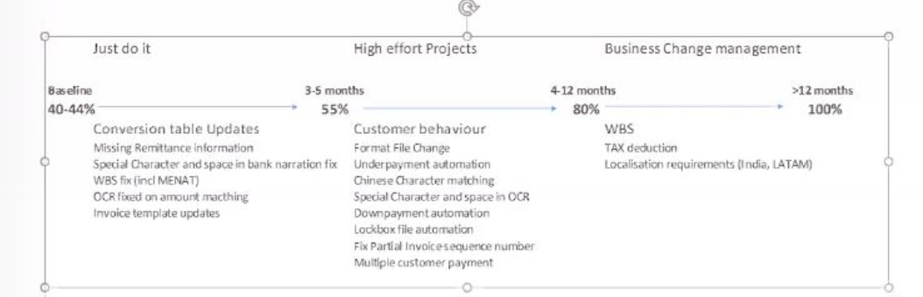

So meanwhile, if we proceed with the website, complete its design and build using the resources available to us, then by **MAY**, with **zero** monetary investment, we have a **70%** functional website ready( without 1. Hosting 2. SSO 3. GE domain name; which requires dependency on other teams).

**Expected scenario in MAY:**

We have a website with all documentation and tools needed for cash automation, available in one single platform.

Post that, if the teams like the website, find the website helpful and we are at a desired automation rate, we can look towards funding it for domain name, hosting and SSO integration.

(Giuseppe said that, post Kaizen event, with I2C and R2R teams working together, team size will increase and so will be the demand of having a website which will increase the convenience of people working on cash transaction and speed up the process. With increase in team size, pulling in fund will be more feasible).

With so many GE sites live on web, I feel for sure we will get a suitable solution sooner or later.

So if we keep up the progress on the website (Simultaneously look for solutions without hindering the speed) then plan for the website:

1. Proceed with WordPress, complete the design part to 100% by march.
2. Reach 60%-70% of build by April.

-----(with guidance from Zoltan and Wendy)

1. 100% design and 100% build by May.

We have a site ready by mid May(latest).

1. Deploy and further steps as per situation post month of May.

**Possible query**

How you will design the section where only few admins can edit the article and not all w/o having GE SSO?

1. Primarily there are 3 people working on content and the site is local in my device. So we can hold a 2 day per week iterative meeting on teams or as and when required and they can take access of my device using teams feature and do the needful changes on website content.